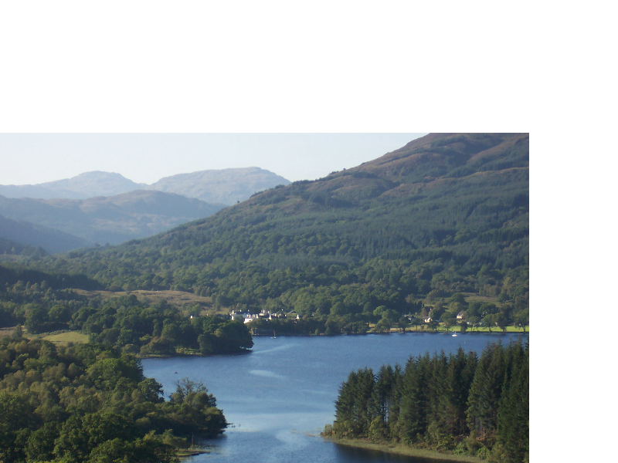LOCH ARD HISTORY GROUP
2016/17 SEASON
Venue: Kinlochard Village Hall. Meeting: Time 19.30
POC: Joyce Kelly (Secretary) Tel 01877 387 292 James Kennedy (Chair) Tel 01877 387 201

October 05 2016: Traditional Building Methods and Materials
Moses Jenkins
November 16 2016: First 100 Years of the Stirling Observer
Donald Morton
December 07 2016: The House I Live In
David Miller (Blairuskin Lodge) Colin Boyd (Torlochan)
January 11 2017: Local Families and their Heraldry
Elizabeth Rhodes
February 1 2017: Argyll and Sutherland Highlanders WW1
Robert Layden
March 1 2017: Rural Schools and their Relationship to their Communities
Helen Young
April Friday 7 2017: Presentations on new South Queensferry Crossing as part of
History Group Away Day to Forth Bridges Contact and Information Centre

