Online Seminar: The photography of Scipio Mactaggart (1812-1886)

Join us online via Zoom on Friday 15 May 2026 at 19:30 UK time to hear Donald MacDougall speak about the work of Scipio Mactaggart: lawyer, public servant and amateur photographer.
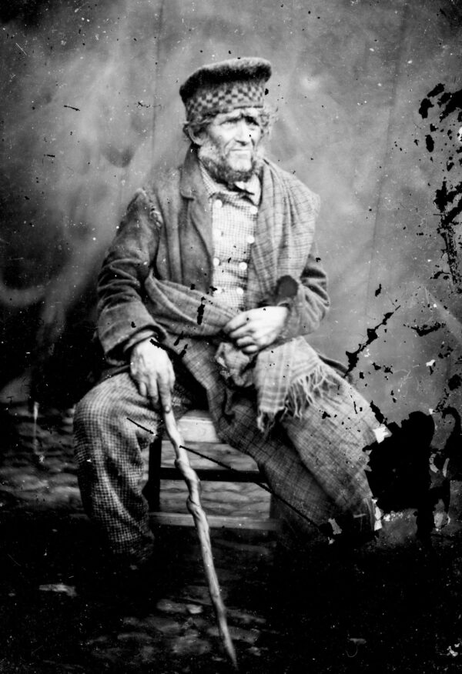
Image: Portrait of a whiskered man in a diced Highland bonnet,
checked tweed suit and plaid (Argyll Estates Archives, SM/02/25).

Born in Campbeltown in 1812, Scipio Alexander Mactaggart studied law at the University of Edinburgh. He later became Sheriff Clerk of Argyll and twice served as Provost of the Burgh of Inveraray (from 1848-54, and again from 1866-68). A weel-kent figure in Inveraray, he took up photography as a hobby in the 1860s, producing a series of outstanding images of the town and its people – among the earliest ever captured.
Donald’s talk will examine how Scipio’s original glass plate negatives were lost, found and subsequently donated to Argyll Estates Archives. He will highlight some of the most striking plates in the collection, showing how they provide valuable evidence of Victorian Inveraray and its inhabitants. Donald will also draw attention to recent conservation work on the plates which has safeguarded them for the future, enabling them to be digitised and made available to all.
Speaker Biography
Donald MacDougall is assistant archivist at Argyll Estates Archives, the family and estate archive of the Duke of Argyll at Inveraray Castle. A native of the Isle of Seil, he studied history and politics before gaining a postgraduate qualification in archival studies from the University of Dundee. He has a keen interest in architectural heritage, especially that of Scottish country houses and their associated landed estates. In his spare time, he helps work the family croft and plays the pipes with Oban Pipe Band.
Booking information
This event is FREE* for members of the Friends.
*Please note: Friends must be logged in to their web account to receive their discount!
Tickets for non-members are £10. Find out more about becoming a Friend here: Become a Friend of Argyll Estates Archives – Friends of Argyll Estates Archives
Alternatively, you can book your place by emailing friends@argyllestatesarchives.org.

