George Miller
Town Clerk of Perth
1723-1763
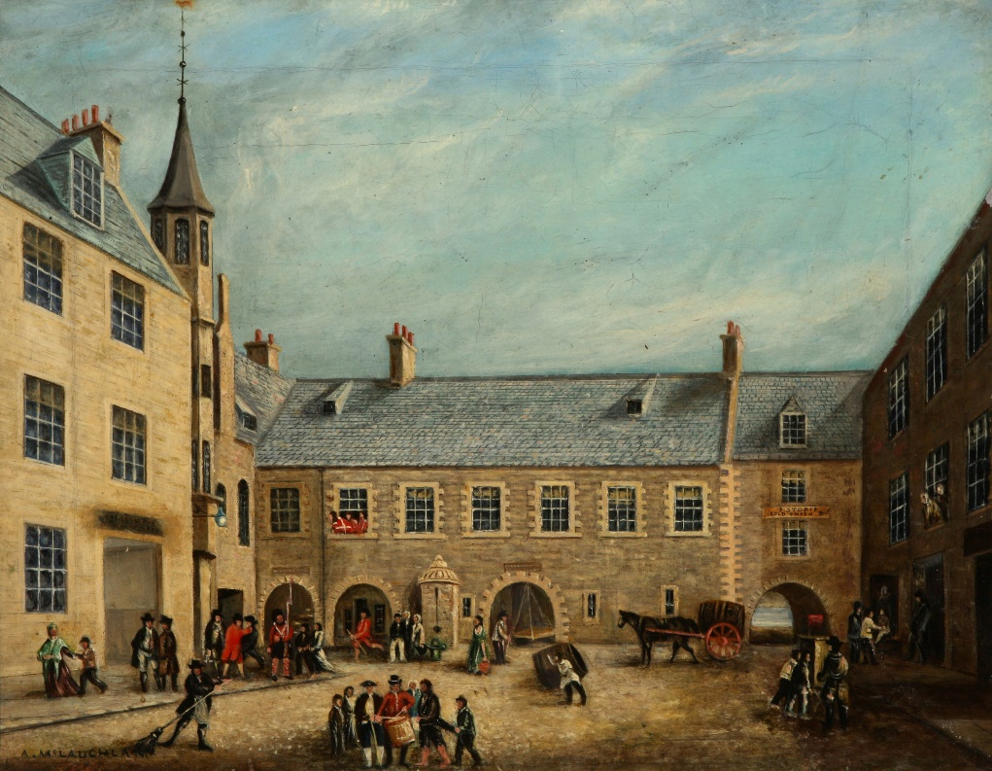
Whig, Hanoverian, Glasite and Anti-Jacobite
Steve Connelly

The Old Town Council House, Perth by Alexander McLauchlan
Courtesy of Perth Museum & Art Gallery, Perth & Kinross Council

