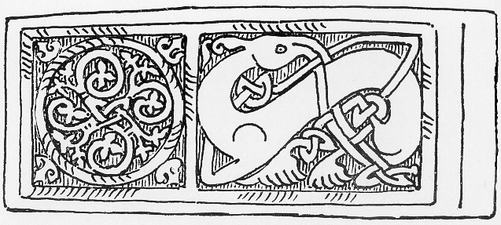

A CELEBRATION OF THE CRICHTON
Past, Present and Future

Sunday September 16th 2018, The Duncan Room, Easterbrook Hall,
The Crichton, Dumfries

A conference organised by the Dumfriesshire and Galloway Natural History and Antiquarian Society, in collaboration with The Crichton Trust

Programme

9.15-10.00 Registration and coffee. Optional attendance at morning service in the Crichton Church ( 9.15-9.45), which will allow delegates to view the interior of the Grade A-listed church and hear the organ.

10.00 Welcome (Dr Jeremy Brock, President, DGNHAS)

Session 1 (Chair, Dr Janet Brennan, who will briefly mention Elizabeth Crichton, founder)
10.05 Morag Williams (former D&G Health Board Archivist): The Early Years and Art Therapy at the Crichton
10.40 Mary Smith (Author and Crichton Graduate): Early Occupational Therapy

11.10 Coffee/tea

Session 2 (Chair, Dr Francis Toolis, who will briefly mention Dr James Gilchrist, 2nd Superintendent and founder of DGNHAS)
11.30 Dr David Hall (Consultant Psychiatrist): Development of Psychiatry at the Crichton
12.05 Ana Sim (Consultant Clinical Psychologist): Distinctive and Innovative: a Brief History of Psychology at the Crichton
12.20 Dr Shirley Turberville (Senior Lecturer in Nursing and Midwifery, UWS): Nursing at the Crichton
12.35 Michael Cook (former General Manager, D&G Health Board) : The Crichton and the NHS

12.55 Lunch (A soup and sandwich lunch, with soft drinks, is provided)

Session 3 (Chair, Alverie Weighill))
13.45 Martin Robertson (National Chairman, The Architectural Heritage Society of Scotland): The Architecture of the Crichton
14.15 Graham Roberts (Archivist, Dumfries and Galloway Council): The Crichton Digital Archive

14.50 Coffee/tea

Session 4 (Chair, Dr Jeremy Brock)
15.10 Prof. David Roberts (Professor of Dairy Farming Systems, SRUC): The Crichton Farm
15.40 Panel discussion: The Crichton: Present and Future:
Prof. David Clark (School of Interdisciplinary Studies, University of Glasgow)
Dame Barbara Kelly, FRSE (Crichton Campus Leadership Group)
Gwilym Gibbons (CEO, The Crichton Trust)

16.25 Closing remarks (Jeremy Brock)

16.30 Tours of grounds/buildings

To register for the conference please complete the booking form. Note that we are unable to accept credit/debit cards for payment. The cost (non-returnable) is £25 per person (£10 for full-time students), including coffee, tea, and lunch. The deadline for registration is August 29 2018

For further information please visit www.dgnhas.org.uk, or contact the DGNHAS President, Dr Jeremy Brock email: president@dgnhas.org.uk
___________________________________________________________________________
Booking Form
To: Crichton Conference, Merkland, Kirkmahoe, Dumfries DG1 1SY

I/we wish to register for the Crichton conference on Sept 16.

Name(s)............................................................................................................................

Address..............................................................................................................................

...........................................................................................................................................

Telephone.............................................. email.................................................................

Any dietary requirements?..................................................................................................

I enclose cheque for £......., payable to 'DGNHAS-CRH Conference' (please enclose SAE if acknowledgment required)
OR
I am making a bank transfer for £...... to the following account:

Account name: DGNHAS-CRH Conference

Account number: 10281762 Sort code 80-11-60

